**BMSN1601 – Tutorial #2**

|  |  |  |
| --- | --- | --- |
| **Name: Wong Kwok Yin** | **UID:** **3036070362** | **Tutor: Ms Caroline Yang** |

**Tutorial Activities**

* + - Please **complete** and **submit** your answers before the tutorial day via appropriate links on Moodle. The deadline for submission of your work is on **4 Oct 2022 (Tuesday) by 11:59 pm**. Late submission/ submission to the wrong link will NOT be entertained.
    - During the tutorial students are expected to actively engage in the discussion and answering tutor’s questions. Your tutor will randomly choose students to answer questions.
    - Please refer the instructions and marking criteria posted on Moodle.
    - **NO model answer** will be posted on Moodle.
    - Please also note that the tutorial content may be assessed in mid-term test and/or the final examination.

-----------------------------------------------------------------------------------------------------------------------------------------------

**Part 1: Lecture content review exercise**

Instructions:

*The following questions are examples of questions that you will encounter in your final examination. Each SAQ carries 10 marks and you are expected to complete each question in 10 min.*

1. Transport of substances across the cell membrane involves different mechanisms.

1. What is the transport mechanism for oxygen molecules to pass through the cell membrane?

|  |
| --- |
| Oxygen molecules can pass through the cell membrane by direct diffusion |

1. Which transport mechanism is dependent on hydrostatic pressure gradient?

|  |
| --- |
| Filtration |

1. Explain the action of the sodium-potassium pump.

|  |
| --- |
| First, sodium-potassium pump binds to sodium ions in cytoplasm which can stimulate phosphorylation by ATP. Then, it changes its shapes, expels sodium ion to ECF and bind potassium ions in ECF due to phosphorylation. The binding of potassium ions releases the phosphate group, which can restore to the original shape of sodium-potassium pump protein. |

1. Which ion is co-transported with glucose across the intestinal wall?

|  |
| --- |
| Sodium Ion |

1. Name TWO types of vesicular transport.

|  |
| --- |
| Exocytosis and endocytosis |

2. Lymphocytes of the lymphatic system are important for host defence against microbial attack.

1. In an adult, name the organ in which lymphocytes are produced?

|  |
| --- |
| Thymus/yellow bone marrow |

1. In which primary lymphoid organ do T lymphocytes mature?

|  |
| --- |
| Thymus |

1. How can B lymphocytes combat microbial infection?

|  |
| --- |
| It produces antibodies to kill macrobacteria |

1. Name two secondary lymphoid organs.

|  |
| --- |
| Lymph nodes and spleen |

1. Oedema is an abnormal accumulation of fluid in the interstitium. Explain why oedema may occur when the lymph veels are blocked

|  |
| --- |
| Lymph is vessel for transferring body fluid from body tissue. If these vessels are blocked, body fluid cannot be recycled and accumulate in the interstitium |

**Part 2: Contextual Learning**

Instruction:   
*The aim of this session is to make connections between knowledge and its applications to your clinical work. Please* ***read*** *the scenario and answer the questions before you come to the tutorial.*

Scenario:

You went on a tour of Ali with your friend Amy in Tibet. Ali is located in the remote west of Tibet, which is 4,300 meter above sea level in the city, and surrounded by mountains. The next morning after arrival, you went along a beautiful trail. You noticed that Amy began to feel unwell. She felt shortness of breath, nausea and fatigue. She also suffered from a throbbing headache and ate just a little due to poor appetite. Since Amy had been physically fit before the tour, you suspected Amy developed acute mountain sickness and immediately got her to a clinic. On examination, Amy’s respiratory rate was 23 breaths per minute and SpO2 was 85% on room air.

Questions:

1. What is the major function of oxygen in our body?

It assists our body cell to break down food into energy in more efficient way be aerobic respiration

1. What is SpO2?

Blood oxygen saturation level. (Peripheral Capillary Oxygen Level)

1. What is the name of the device that we use to rapidly measure SpO2 of a patient?

Pulse oximeter.

1. What are the normal ranges of SpO2 and respiratory rate?

96 % or above.

1. Are Amy’s RR and SpO2 within normal range? Explain.

Normal breath rate is 12 to 16 breath per minute, while normal range of SpO2 is 95% or above. However, Amy’s RR is 20 breathe per minute and her SpO2 is 85%, these data are not in the normal range.

1. What are the symptoms of acute mountain sickness?

Feeling dizzy, headache, having rapid breathing

1. How do you relate atmospheric pressure to altitude?

Atmospheric pressure decreases with altitude

1. Amy suggested her discomfort was caused by the less concentrated oxygen at high elevations. However, you know that oxygen still makes up roughly 21% of the atmosphere at high altitudes. How would you explain to Amy? (Hint: Your answer in the previous question and Dalton’s Law)

She feels unwell because of insufficient oxygen supply. Even though the oxygen concentration at high altitude is roughly the same as normal, atmospheric pressure in high altitude is much lower than in normal altitude. According to Dalton’s Law, atmospheric pressure is directly proportional to gas volume. Thus, the oxygen volume is lower than normal, so she is inhaling less amount of oxygen than normal.

1. Compare PO2 and PCO2 in alveoli to that in atmospheric air and in the blood entering pulmonary capillaries respectively. Describe the mechanism of gas exchange between alveoli and pulmonary capillaries.

In atmospheric air, PO2 is 159mm Hg and PCO2 is 0.03mmHg. While in alveoli, its PO2 and PCO2 are 100mm Hg and 40mm Hg respectively. Thus, atmospheric air has a high PO2 than in alveoli, and it has a lower PCO2 than in alveoli. PO2 and PCO2 in the blood entering pulmonary capillaries are 40mm Hg and 46mm Hg respectively.

It is noted that the PO2 in it is far lower than in alveoli and its PCO2 in it is higher than in alveoli. As there are pressure gradients between alveoli and pulmonary capillaries, it promotes oxygen and carbon dioxide exchange by diffusion across systemic capillary membranes in respiratory membrane

1. Based on the Hb-O2 saturation curve provided below, estimate Amy’s arterial partial pressure of O2 from her SpO2 value.

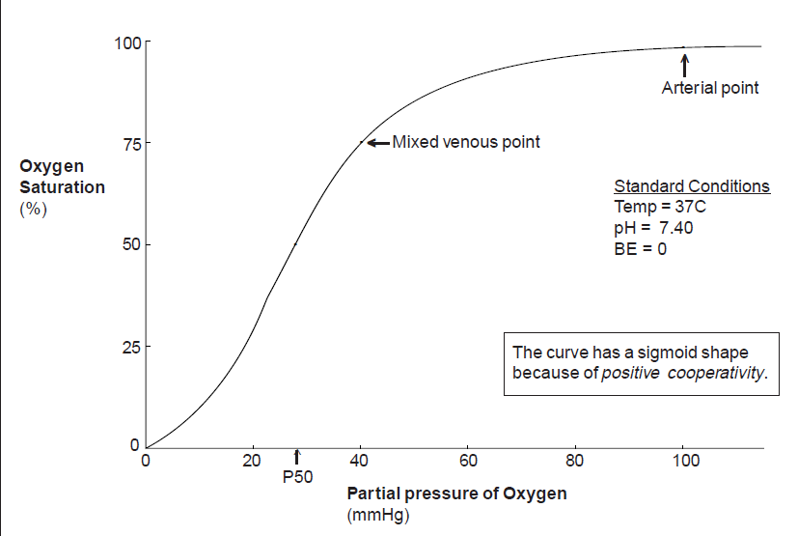

**Hb-O2 saturation (%)**

**PO2 (mmHg)**

55mm Hg

1. Do you expect any change to the Hb-O2 dissociation curve and Hb-O2 affinity in Amy’s condition? Explain your answer. (Hint: Amy’s breathing rate and PCO2)

As the atmosphere pressure is decreased, the diffusion rate of CO2 to the surrounding is higher because of larger pressure difference in intrapulmonary pressure and atmosphere pressure. In addition, Amy’s breathing rate is also higher. Thus, PCO2 in blood decrease seriously in blood which result in high pH values of blood. Under this situation, Hb-O2 dissociation curve move to the left and Hb-O2 affinity is higher.

1. Distinguish between hypoxemia and hypoxia.

Hypoxemia means low oxygen concentration level presence in blood while hypoxia means insufficient amount of oxygen for the cells in the body.

1. After resting overnight, Amy felt much better. She wondered why the nurse, who was a local resident in the town, did not have any problem with living at high altitude.

Body of local resident in the town may produce more red blood cell than Amy, in order words, the concentration of Hb is much higher and percentage of Hb-O2 saturation is also higher to keep the homeostasis.